**LAB 09**

**HYPOTHESIS TESTING**

**Aim: To analyze Normal Distribution in R**

**Input:**

**# This code performs a one-sample z-test and a hypothesis test on the efficiency of a hospital.**

**# First, we define the variables.**

**xbar = 14.6 # sample mean**

**mu0 = 15.4 # population mean**

**sigma = 2.5 # population standard deviation**

**n = 35 # sample size**

**# We then calculate the z-statistic.**

**z = (xbar - mu0) / (sigma / sqrt(n))**

**z**

**# We set the alpha level to 0.05.**

**alpha = 0.05**

**# We calculate the critical value.**

**zhalfalpha = qnorm(1 - (alpha / 2))**

**zhalfalpha**

**# We calculate the p-value.**

**pval = 2 * pnorm(z)**

**pval**

**# If the p-value is greater than the alpha level, we accept the null hypothesis.**

**if (pval > alpha) {**

**print("Accept Null Hypothesis")**

**}**

**# Next, we define the variables for the hypothesis test on the efficiency of the hospital.**

**n = 640**

**p = 63 / n**

**P = 0.1726**

**Q = 1 - P**

**# We then calculate the z-statistic.**

**z = (p - P) / sqrt((P * Q) / n)**

**z**

**# We calculate the critical value.**

**E = qnorm(0.975)**

**E**

**# We calculate the confidence interval.**

**c(-E, E)**

**# We determine if the hospital is efficient.**

**if (z > -E && z < E) {**

**print("Hospital is not efficient")**

**} else {**

**print("Hospital is efficient")**

**}**

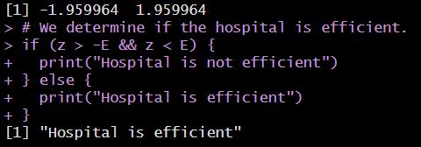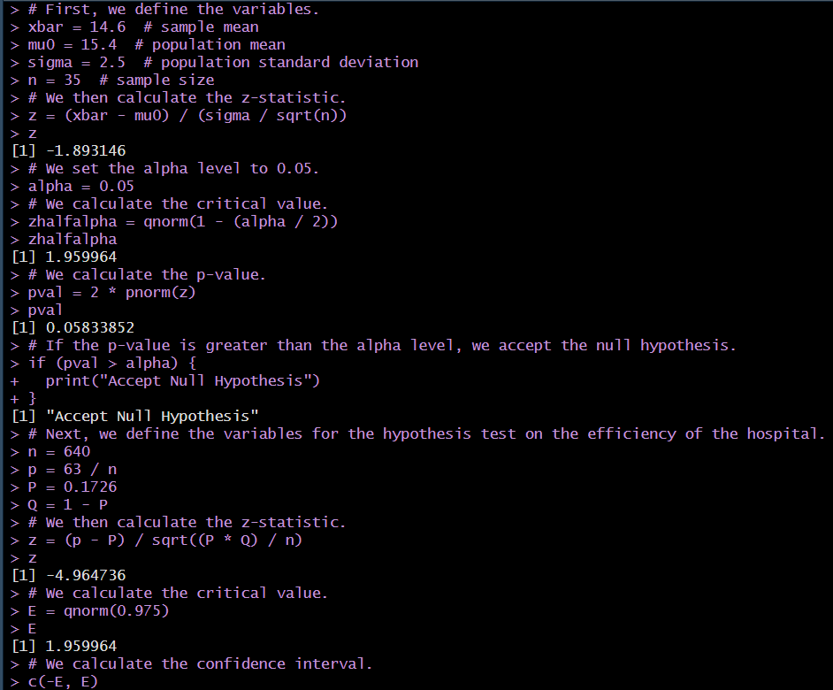**OUTPUT:**

**Inference:**

**If the pval>alpha then H0 hypothesis is accepted or else it H0 is not accepted.**

**\*\*\*\*\*\*\*\*\*\*\*\*\*\*\*\*\*\*\*\*\*\*\*\*\*\***